Um weitere interessante Genesets zu finden, werden die hallmark gene sets der MSigDB Datenbank angeschaut.

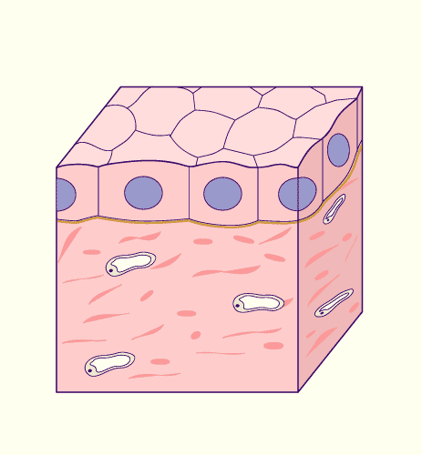Bei PRAD handelt es sich um Karzinome. Demnach wäre es interessant, gene sets mit Bezug auf epitheliale Zellen zu wählen:

* [HALLMARK_APICAL_JUNCTION](https://www.gsea-msigdb.org/gsea/msigdb/cards/HALLMARK_APICAL_JUNCTION.html): Genes encoding components of apical junction complex.
* [HALLMARK_APICAL_SURFACE](https://www.gsea-msigdb.org/gsea/msigdb/cards/HALLMARK_APICAL_SURFACE.html): Genes encoding proteins over-represented on the apical surface of epithelial cells, e.g., important for cell polarity (apical area).

Ausßerdem sind oft erbliche bedingte Faktoren, u.a. die DNA-Raparaturgene mutiert (https://www.dna-diagnostik.hamburg/analysen/karzinom-prostata/):

* [HALLMARK_DNA_REPAIR](https://www.gsea-msigdb.org/gsea/msigdb/cards/HALLMARK_DNA_REPAIR.html): Genes involved in DNA repair.

Nur männliche Patienten:

* [HALLMARK_SPERMATOGENESIS](https://www.gsea-msigdb.org/gsea/msigdb/cards/HALLMARK_SPERMATOGENESIS.html): Genes up-regulated during production of male gametes (sperm), as in spermatogenesis.

Darüber hinaus wurden entsprechend zu den hallmarks of cancer (Hanahan, Weinberg 2011) passende gene sets gewählt. Teilweise wird es zu Überschneidungen zu den vorgegebenen gene sets kommen.

Zellzyklus:

* [HALLMARK_G2M_CHECKPOINT](https://www.gsea-msigdb.org/gsea/msigdb/cards/HALLMARK_G2M_CHECKPOINT.html): Genes involved in the G2/M checkpoint, as in progression through the cell division cycle.

Avoiding immune destruction:

* [HALLMARK_COMPLEMENT](https://www.gsea-msigdb.org/gsea/msigdb/cards/HALLMARK_COMPLEMENT.html): Genes encoding components of the complement system, which is part of the innate immune system.

Tumor promoting inflammation:

* [HALLMARK_INFLAMMATORY_RESPONSE](https://www.gsea-msigdb.org/gsea/msigdb/cards/HALLMARK_INFLAMMATORY_RESPONSE.html): Genes defining inflammatory response.

Activating invasion and metastasis:

* [HALLMARK_EPITHELIAL_MESENCHYMAL_TRANSITION](https://www.gsea-msigdb.org/gsea/msigdb/cards/HALLMARK_EPITHELIAL_MESENCHYMAL_TRANSITION.html): Genes defining epithelial-mesenchymal transition, as in wound healing, fibrosis and metastasis.

Inducing angiogenesis:

* [HALLMARK_ANGIOGENESIS](https://www.gsea-msigdb.org/gsea/msigdb/cards/HALLMARK_ANGIOGENESIS.html): Genes up-regulated during formation of blood vessels (angiogenesis).

Genome instability & mutation:

* [HALLMARK_REACTIVE_OXYGEN_SPECIES_PATHWAY](https://www.gsea-msigdb.org/gsea/msigdb/cards/HALLMARK_REACTIVE_OXYGEN_SPECIES_PATHWAY.html): Genes up-regulated by reactive oxigen species (ROS).

Resisting cell death:

* [HALLMARK_APOPTOSIS](https://www.gsea-msigdb.org/gsea/msigdb/cards/HALLMARK_APOPTOSIS.html): Genes mediating programmed cell death (apoptosis) by activation of caspases.

Deregulating cellular energetics:

* [HALLMARK_HYPOXIA](https://www.gsea-msigdb.org/gsea/msigdb/cards/HALLMARK_HYPOXIA.html): Genes up-regulated in response to low oxygen levels (hypoxia).
* [HALLMARK_GLYCOLYSIS](https://www.gsea-msigdb.org/gsea/msigdb/cards/HALLMARK_GLYCOLYSIS.html): Genes encoding proteins involved in glycolysis and gluconeogenesis.
* [HALLMARK_FATTY_ACID_METABOLISM](https://www.gsea-msigdb.org/gsea/msigdb/cards/HALLMARK_FATTY_ACID_METABOLISM.html): Genes encoding proteins involved in metabolism of fatty acids.
* [HALLMARK_OXIDATIVE_PHOSPHORYLATION](https://www.gsea-msigdb.org/gsea/msigdb/cards/HALLMARK_OXIDATIVE_PHOSPHORYLATION.html): Genes encoding proteins involved in oxidative phosphorylation.
* [HALLMARK_CHOLESTEROL_HOMEOSTASIS](https://www.gsea-msigdb.org/gsea/msigdb/cards/HALLMARK_CHOLESTEROL_HOMEOSTASIS.html): Genes involved in cholesterol homeostasis.
* [HALLMARK_BILE_ACID_METABOLISM](https://www.gsea-msigdb.org/gsea/msigdb/cards/HALLMARK_BILE_ACID_METABOLISM.html): Genes involve in metabolism of bile acids and salts.
* [HALLMARK_HEME_METABOLISM](https://www.gsea-msigdb.org/gsea/msigdb/cards/HALLMARK_HEME_METABOLISM.html): Genes involved in metabolism of heme (a cofactor consisting of iron and porphyrin) and erythroblast differentiation.
* [HALLMARK_XENOBIOTIC_METABOLISM](https://www.gsea-msigdb.org/gsea/msigdb/cards/HALLMARK_XENOBIOTIC_METABOLISM.html): Genes encoding proteins involved in processing of drugs and other xenobiotics.
* [HALLMARK_PEROXISOME](https://www.gsea-msigdb.org/gsea/msigdb/cards/HALLMARK_PEROXISOME.html): Genes encoding components of peroxisome

